**Soldering tips and guide for PCB**

By Kevin Tang

1. **Objective**

The goal of this paper is to present the methodology behind soldering components onto a printed circuit board, along with presenting tips and helpful approaches along the way. Soldering is important since it is necessary to have each component placed on the correct pads of a PCB to ensure that it is functional. The two primary methods of soldering done for the PCB’s are with the use of a hot plate and the soldering iron.

1. **Introduction**

For the Frequency-Modulated Continuous-Wave radar system design, all of the original components from the final lab from fall quarter are replaced by integrated circuits and surface mount passive components that can be soldered onto the printed circuit board. The printed circuit board supports and connects the components along with resistors and capacitors through their conductive tracks and pads. The way to connect these components is through the use of solder to melt and create a connection between the component and the pad. Solder is a type of material that is used to connect a component with the circuit board. For our radar system, there are two different printed circuit boards to solder everything onto; one is the board that is primarily composed of the RF components, and the other being the baseband board.

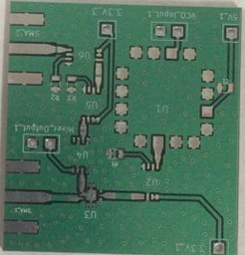

**Figure 1. RF PCB**

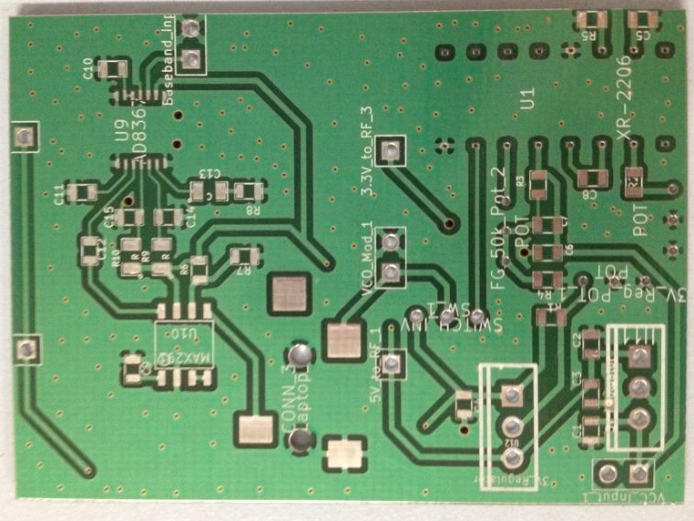

**Figure 2. Baseband board**

1. **Methods of soldering**

There are two different methods of soldering on the components onto the printed circuit board that our group used. The primary method is with the use of a soldering iron that supplies heat to melt solder to create a connection between the surface mount and the pad on the board. The second method would be the use of a hotplate with the assistance of solder paste. Both methods are equally as useful for putting together the board.

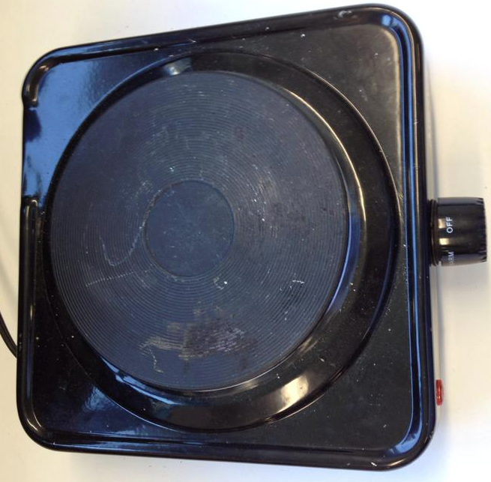

**Figure 3. Hotplate**

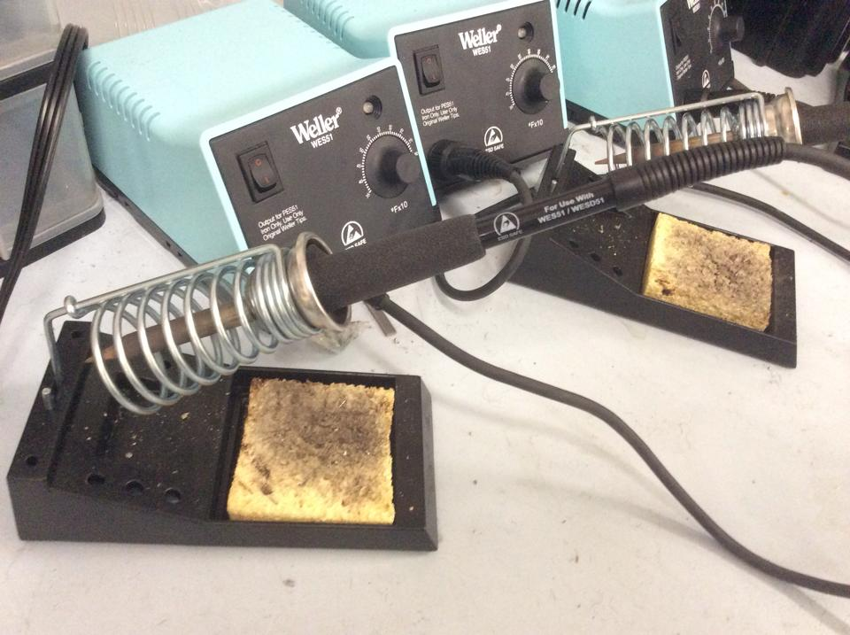

**Figure 4. Soldering Irons**

1. **Use of a hotplate**

For the radar system, both methods were implemented for soldering the printed circuit board. The hotplates were used for the RF components such the VCO, Power Splitter, amplifiers, etc. Using the hotplate for the RF surface mount components seemed to be the most efficient way since the components were generally much smaller and it would become more difficult to create clear, direct connection with the use of the soldering iron.

To use the hot plate, first the solder paste must be applied to each individual pad on the circuit board to guarantee that there would be a connection. It is important to not over-apply the solder paste that would cause it to overflow the pad. Solder can overflow one pad onto a nearby pad and this could be the source of something not functioning on the board. Once the paste is on, each component would be put in their respective locations and it is important to line them up with their pads. It was much more efficient using the solder paste for these RF components since the surface mount size for some components can be as small as 0.25 mm by 0.51 mm. Components this small can be incredible difficult to solder on with the use of a soldering iron alone so the hotplate was deemed to be the most suitable.

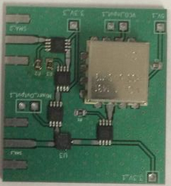

**Figure 5. Solder paste with components placed on top**

Once complete the PCB would be put onto the hotplate and we generally set it to be 255 F for about 30 seconds to a minute, until there is a slight shift in the height of the component that signifies the melting of the paste. The paste also turns into like a silver color and this indicates that the solder paste has been heated sufficiently and has melted. Soon after the paste becomes shiny, it is a good time to remove the board from the hotplate as having burned circuit components is unwanted. For surface mounts this may not be an issue but for through holes, it’s important to remember that the solder paste may leak through the hole. It is important to not use your bare hands to move the PCB immediately after this process as the board does not cool down immediately.

It is best to use tweezers to move the circuit board and put it aside until it cools down. The components on the board may also shift rather easily so it is important to keep it upright until the solder paste is cooled down to solidify the connection when removing it from the board as this may have occurred once during the process of using the hotplate. When it has cooled down, it is important to make sure that none of the pads are connected by an overflowing amount of solder as that may cause problems on the board. It is important to limit the amount of soldering paste placed initially prior to using the hotplate.

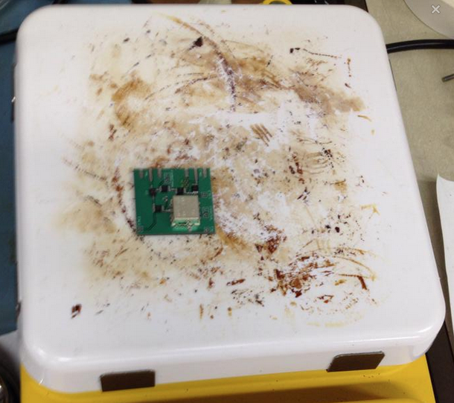

**Figure 6. Use of hotplate to place components.**

With the hotplate it is important to try to apply the solder paste and all of the components on the board at once initially, rather than try to individually place them on. The reason behind this is that some components may not be able to stand the heat through the second use of the hotplate and may melt. It is best to not to use the hot plate a second time after the initial usage of the plate since the board could be ruined this way. For example, a single component was soldered onto the board using a hotplate. Once the board is cooled down, you decide to solder on another component with the hotplate. The second use of the hotplate could possibly cause the component that is already on the board to melt since components can melt after leaving it on there for a long period of time as some components may not be able to stand being in such high heat for long periods of time. Overall, the hotplate is excellent for soldering on components onto a printed circuit board.

1. **Use of the Soldering Iron**

The components on the baseband board were soldered on primarily using a solder iron with solder and flux.The resistors and capacitors come in the package size of 0603(1.6mm x .8 mm) and 0805 (2.0 mm x 1.25 mm) for our design and they can be soldered on using either methods of soldering based on the users’ preference as both techniques were used for our designs.

When using the soldering iron, it is important to use flux prior to adding the solder onto the board. Flux is used to assist in the soldering process as it helps remove anything unclean that would cause the soldering to be unsuccessful. They usually come in syringes to make applying the flux easier as it is not advised to add too much onto the pad. It is important to use flux to achieve a more successful connection with the component and the pad. Below is an example of how much flux should be added onto each pad. Too much flux may become problematic when dealing with the hotplate since components may shift more easily.

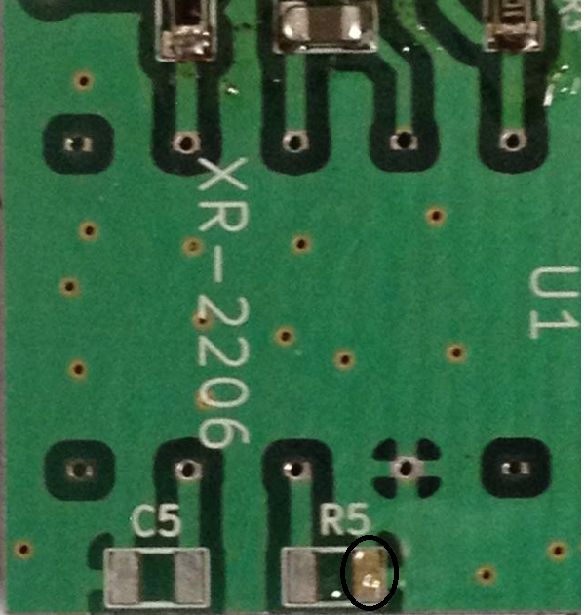

**Figure 7. Flux and Solder on a pad**

Once the flux is applied, solder must then be melted onto the pad. In order to solder the resistors on you must first melt a bit of soldering onto the pad as seen above. The solder causes the components to connect to the board. Once that is done, the soldering iron is used by placing it onto the corner of the pad in order to heat up the solder, causing it to liquefy so it is possible to push the resistor or capacitor onto the pad. After it is in place, the soldering iron is removed and the resistor should be solidified on top of the pad, therefore establishing the connection. It’s important the make sure that this connection is concrete so the resistor or capacitor will not move from this position. A magnifying glass is recommended for checking the connections as it may be difficult to check for these smaller components. The opposite end is simpler to solder on as it is placing the soldering iron near the solder to cause it to melt on top of the other end of the resistor to complete the linking of the two. The soldering iron is generally useful for the bigger components like the audio jack for our board.

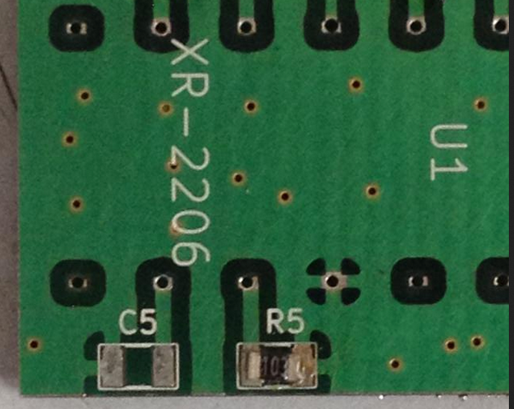

**Figure 8. Initial soldering of passive**

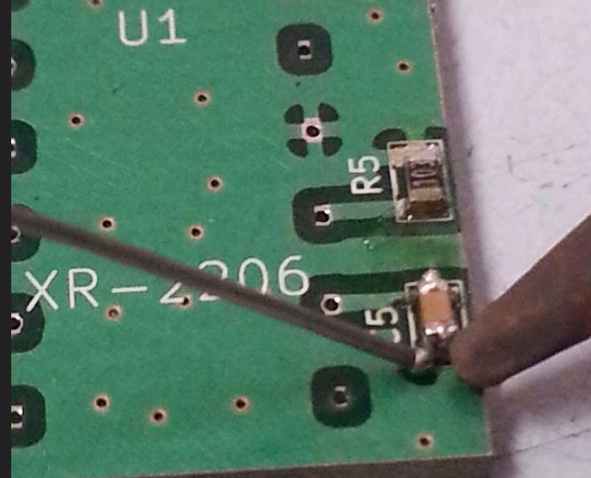

**Figure 9. Completing connection**

1. **Tips**

One mistake people often make while soldering is both applying too much solder since it would make it difficult to see if the pad and the components are actually connected. Having too much soldered on a pad that is close to another pad may cause a short and it add extra capacitance It would be advised to remove as much solder as possible, but also leaving enough to retain a connection. So it is necessary to check if the component is actually connected to the pad and to make sure no solder from one pad overflows to a nearby pad. The latter generally is not an issue for resistors and capacitors but for the smaller components like the LNA the pads are relatively close so solder from one pad may overflow onto the other pads. A copper braid may be used to remove the excess solder by heating up the material and putting the copper braid on top of the unwanted solder.

Another thing to note is the different type of soldering irons. There are two types of soldering irons that were accessible, one with the more refined tip and another with a larger rounder tip. Both soldering irons are perfectly fine for soldering on components. Since the package for the resistors and capacitors are 0603 are 1.6mm by.8 mm, which are small. The more refined tip might be better to use for soldering on the circuit board. The wider tip is still capable of getting the soldering job done but it may be more beneficial to use the sharper tipped soldering iron as it would be more accurate in placing the solder on top of the pads for a direct connection. This would make soldering on the components more precise, therefore removing possible connection errors that could potentially exist.

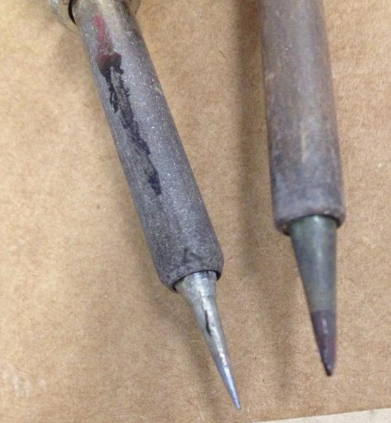

**Figure 10. Comparison of different solder irons.**

An issue that may occur when sending in a design to a manufacture is that the through-hole size may not be correct. One mistake made while designing the footprints for the through hole XR-2206 was using the minimum dimensions given to us on the data sheet. As seen below, the most important factors to look at when designing the PCB are the parameters C and B. The mistake made here was using the dimensions .008 inches and .014 inches for the width and length of the component rather than using something in between the maximum and minimum. Because of this mistake the XR-2206 cannot be placed through the whole, but only on top of the board.

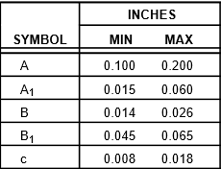

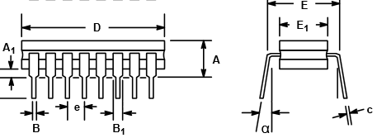

**Figure 11. Datasheet for XR-2206**

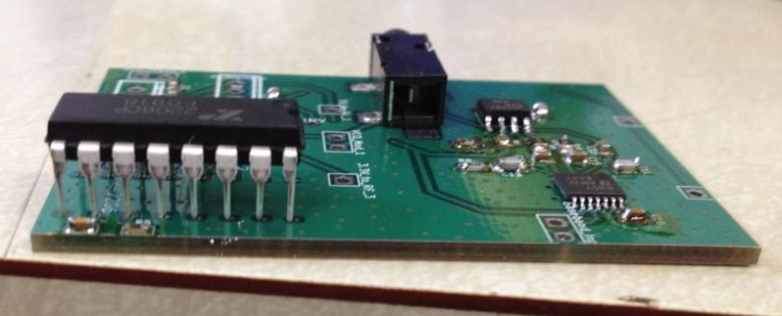

**Figure 12. Pin hole size being too small for component**

Having smaller hole sizes does not necessarily mean it is impossible to solder on the component to have a concrete connection. One important thing about the XR-2206 chip is that this only works for low frequencies. At higher frequencies, if the pads were not the correct dimensions this would not be functional. However, this may not be detrimental to the results since through holes are primarily for low frequencies. A connection between the XR-2206 chip and the through hole can still be established through various methods.

One way to fix this is to solder the piece right on top of it, despite it not being able to go through and this component will work as intended. The first attempt at soldering the XR-2206 was with a soldering iron but not all of the connections were there for each pin. There was not a direct joint between all the legs of the XR-2206 and the through holes. The second option is using the hotplate, placing solder paste on top of the through holes and letting the paste melt to establish a connection. One thing to note for this method is that some of the paste may seep through the hole, leading to not enough paste to establish a joint connection. A third option is placing the XR-2206 component onto a bread board and then feeding the wires into the through holes on the board. The wires would then be soldered onto the board to guarantee that the chip would be connected to the board in order to be used as the function generator.

1. **Testing the connections**

For the PCB it is important to test the connections after soldering on the component and one approach for this is to solder and test one component at a time. Below is an example of the Low Noise Amplifier on the PCB alone. For an active component, it is necessary to apply a dc power to the board in order to see how much current it runs. If there is a current running, then the component is powering on and is soldered onto the board correctly. It’s also important to remember to solder on the resistors, capacitors, and inductors that are given through the datasheet when examining the current to see if the value is correct since the resistor value sets the current. That is primarily for testing if the design specifications and everything on the board is working properly. This could be done for individual components to see if the soldering is complete and everything is connected.

The testing for current in each component is important for high frequency since there was no simple method to probe the system to see an RF signal. This is because of the reflection caused in high frequency circuits if there was any impedance mismatch. So for higher frequencies, the testing is primarily done by looking at the current for the components. Since there was no easy way to probe at specific points, it makes it difficult to pinpoint the source of the errors that may occur on the board. For low frequencies, a probe may be used simply to test voltages and see if the passive or active components are working properly.

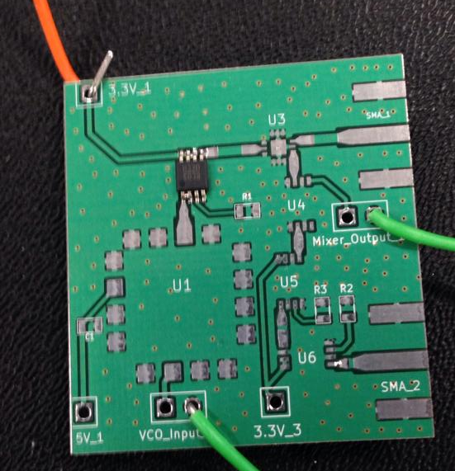

**Figure 13. Testing**

One important thing to note while testing if the component is soldered on correctly is the amount of solder placed on each pad. Solder paste and a heating iron was used for these smaller components and initially too much solder was placed onto the pads. Solder from one pad melted and connected with the pad that it was next to it and caused a short. The way to fix this is to try to remove some of the solder or remove the component completely and then try to put it on again with less solder. It is important to limit the amount of solder placed on each pad to guarantee that the component is soldered on successfully. This can be done for various other components to examine if everything is soldered on correctly.